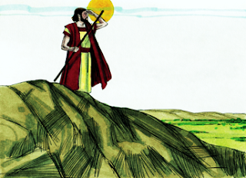
Some time passed after Babel and people had children and they had children. Terah (Tee’rah) had Abram. Abram was married to Sarai, (Sar’eye) and they didn’t have any children. He was very rich in livestock, silver and gold He lived in Canaan.
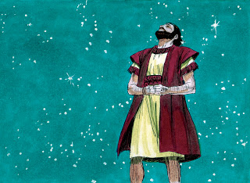
Today's scripture is Genesis 17:1-18:16; 21:1-5; 22:1-13. When Abram was 75 years old, God appeared to him. (Genesis 12:1-7) Even though Abram didn’t have sons, God told him to “Look toward the heaven and count the stars, if you can and that is how many descendants you will have.” (Genesis 15:5-6) Abram believed what God told him. He said that Abram would be “a father of many nations” and now his name would be Abraham. Nations and kings would come from his descendants. Also, now his wife will be called Sarah.
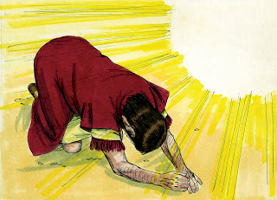
Many years later, God talked to Abraham told him that He would bless Abraham and Sarah with a son and she will be a mother of all nations. How do you think Abraham felt about this? He actually fell on his face and laughed! (Genesis 17:17) Abraham asked God “How can I have a son when I’m 100 years old and my wife is 90?” God told him that Sarah would have a son and they are to call him Isaac and she would have him next year.
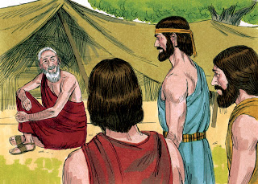
Later, Abraham was sitting by the door of his tent and when he looked outside, there were three men. He ran out to meet them and offered them water, rest, food and feet cleaning. He had Sarah make bread, and he took a good calf and had someone cook it.
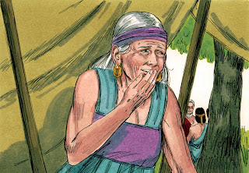
They asked Abraham where his wife was and he told them “She is here in the tent.” Sarah was listening by the tent door and heard one of the men say that she would have a son. Well, she knew she was old and she laughed to herself.
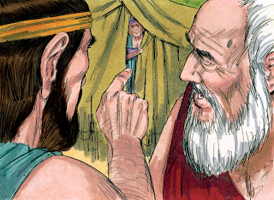
Now the man asked Abraham why Sarah laughed because can’t God do anything? Sarah became afraid and denied that she had laughed, but He said “Yes you did.” The men rose and Abraham went with them to send them on their way.
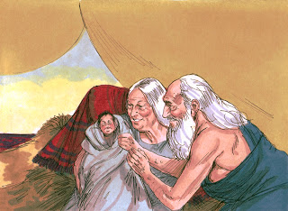
The next year, Sarah had their son and they named him Isaac just as God told them to.
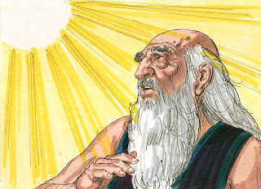
More time passed and God called to Abraham and told him “There’s a mountain that I want you to go to and take your son Isaac.” So, Abraham got up early, saddled his donkey, and took two men and Isaac. He went where God told him to and on the third day he saw the place that God wanted him to go. He told the young men to stay there because Isaac was going with him to worship.
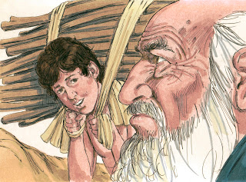
Abraham took the wood, fire and a knife for the offering. Isaac said “But, father, we have everything for the offering, but where is the lamb?” Abraham told him that God would provide it.
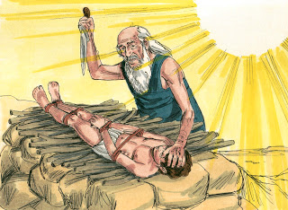
Abraham built an altar and put the wood on it. He tied up Isaac and laid him on the altar and lifted his knife to kill him. But the Angel of God came and called out his name and told him not to hurt Isaac. Now I know that you fear God. Abraham looked up and there was a ram caught in a thicket.
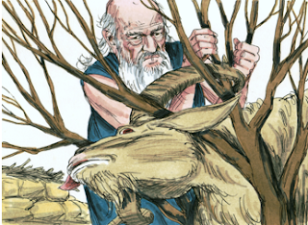
He took the ram and offered it up as a sacrifice instead of Isaac. Compare this to God being willing to send His Son to be offered as a sacrifice for us. He didn’t ask Abraham to do something that He wouldn’t do.

