Tuesday 17th May
Hi Year 5,
I hope you liked my jokes on the bottom of yesterday’s newsletter! Now to work!

English – Reading Comprehension

Maths – Time
Now that you can tell the time on anlogue and digitial formats have a go at reading the bus timetable and answering the following questions. This is a useful activity as you will need to read bus and train timetables as you get older, maybe even to go to school. If you miss a bus you need to know when the next one will arrive ect.
Watch the video clip to help you if you are not sure how to complete the activity.
https://www.bbc.co.uk/teach/class-clips-video/maths-ks2-using-timetables/zn2hy9q

Geography – World Maps, Locations, Habitats.

Use the picture of the World map and plot where different animals originate from and research why they live in these environments. Things you might want to research/consider are: food sources, climate, weather and terrain.
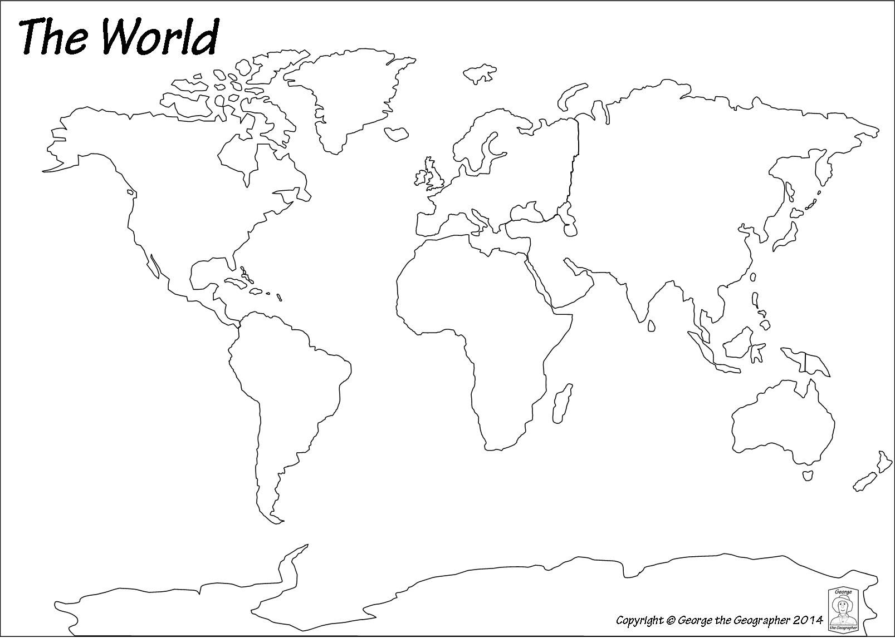

If you want to you could enlarge the size of the map and draw or cut and paste animals to map your map more interesting. You could bullet point facts about the habit and environment around each country.

Have a lovely day,

Mrs Williams

